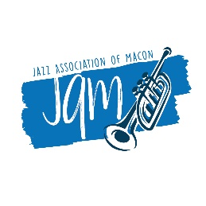

2020 Musicians Relief Fund Application

Your Full Name ________________________________________________________________

Home Address __________________________________________________________________

__________________________________________________________________

Phone - cell _____________________ Phone – home/work ____________________________

E-Mail _____________________________________________________________________

Family ____ Single ____ Spouse/Partner _____ Minor Children, ages _____ Other ________

Professional Name, Band or Group (if any) ______________________________________________

Music Expertise (instrument, genre) _____________________________________________________

Musician Status ______Full time, no other employment _____Full time & other employment

______Part-time, no other employment ______Part-time & other employment

_______Other employment has also been lost

JAM Status (if any) _____JAM Member _____Played at JAM Event _____Volunteer at JAM Event

Funds requested for ______Rent/Mortgage ______Food _______Car payment/transportation

_____Health Services ____Instrument repair/retrieval

_____Other (Please explain)____________________________________________

What is the COVID-19 Impact on your work as a professional musician?

_____All previous work lost, unable to perform due to federal/state guidelines

_____All previous work lost, have not received State unemployment or federal subsidy

_____More than 50% of income lost, unable to find other work

_____No other source of funds for the family available at this time

Open to musicians who reside in Middle Georgia. Submit form to jazzmacon@gmail or mail to JAM, P.O. Box 4192, Macon, GA 31208 by May 31, 2020. Applications submitted after May 31 may not be eligible for consideration.

