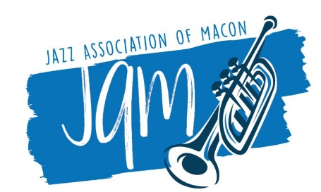

Contact: Tom Woodbery (478) 737-2771

Mary-Katherine Lewis Wins Marc Whitten Memorial Music Scholarship

Macon, GA – June 26, 2020 – The Jazz Association of Macon has awarded the Spring 2020 Marc Whitten Memorial Music Scholarship to Mary-Katherine Lewis.

She is a rising 8th grade student at Miller Fine Arts Magnet Middle School in Macon who started playing the cello when she was nine years old. She has performed in the Bibb District Honor Orchestra. Her orchestra director, Dr. Kuei-Fan Chen, says “Mary-Katherine displays great responsibility, teamwork and a positive attitude in my class.” She will use the scholarship for her cello and individual music lessons.

The scholarship is named in memory of Marc Whitten, a Macon artist and musician who suffered from Crohn’s disease and died in 2018 at age 44. The scholarship is available to area middle and high school and college students who demonstrate a love for and commitment to music through their school band or chorus.

“We created this scholarship as a tribute to Marc’s love of music and music education,” said Whitten’s parents, Rick and Sue. “Our goals are to help recipients enhance their understanding and appreciation of music and to honor the short life of Marc Whitten.”

About Marc Whitten
Marc Whitten had a life-long appreciation for music and art. He began playing the saxophone in middle school, finally settling on the guitar as his instrument of choice. At both Emory University and the University of Georgia, he was a serious student of music theory. Marc suffered from Crohn’s disease from the age of 12 until his death at age 44 in 2018. His passion for music helped him cope with the difficulties of his illness. With a strong interest in music education, Marc took great delight in sharing his love of music (especially guitars) with others.

About Jazz Association of Macon (JAM)
Established in 1986, JAM is a nonprofit organization devoted to advancing education and appreciation of jazz as a uniquely American art form. JAM scholarships go to middle school and high school musicians, and local musicians perform jazz education sessions in area schools. JAM’s signature free event, featuring live local music and artisans, is Jazz and Arts on Riverdale, which will be Saturday, October 24, 2020. Learn more at www.maconjazz.org and https://www.facebook.com/MaconJAM

